

**Daffodil International University**

**Software Engineering Project-1**

**For**

**ATM BOOTH MANAGEMENT**

This work is based upon the submission of the fall 2017

SWE 221: “Software Engineering Project-1 (Using C), Department of Software Engineering (22th Batch)

**Submitted To**

**MD. Habibur Rahman**

**Lecturer, Department of software Engineering of DIU**

**Debashish Roy Janip Al Helal**

**ID : 171-35-2050 ID:171-35-2046**

**Batch : 22 Batch : 22**

**Sec : F Sec : F**

**APPROVAL:**

A report on **“ATM Booth Management**”,

Submitted by

Debashish Roy,

ID : 171-35-2050. Batch 22th, Semester: Fall 2017

Janip Al Helal,

ID:171-35-2047, Batch 22th, Semester: Fall 2017

In the Department of Software Engineering (SWE) Of Daffodil International University, Dhaka. has been accept as satisfactory for partial fulfillment of the requirement for the degree of B.Sc in Software Engineering under the course SWE231: Course Title: “Software Engineering Project-1”

**Signature of Supervisor**

|  |
| --- |
|  |

**Md. Habibur Rahman**

Lecturer

Department of Software Engineering

Daffodil International University

102 Mirpur Rd, Dhaka 1207

**Preface:**

Special thanks…

Special thanks to Dear Sir Md. Hamidur Rahaman Sir. He helps to make our project easy and gives instruction of our project. He always gives us inspiration and motivation. He always gives his best on our project. We also gratitude to the sir for his valuable time and solving our critical problems…

And we wish thanks to my friends for their helpful cooperation…

**ACKNOWLEDGEMENT:**

The authors feel proud to have the opportunity to express their heart-felt and most sincere gratitude to a number of peoples who have them in courses of this project.

This project was performed under the supervision of MD. Hamidur Rahman Lecturer, Department of Software Engineering (SWE),Daffodil International University, 102 Mirpur Rd, Dhaka 1207. First and foremost, the authors wish to concede their profound indebtedness to him for guidance, valuable suggestions, encouragement and cordial cooperation.

We are also grateful to the rest of the teachers of our respective Department, Department of Information & Communication Technology for helping us in many ways.

Heartiest thanks to my Department of the University, Software Engineering for providing me such an opportunity for the accomplishment of our project smoothly.

Lot of thanks to those who were the respondents of our project work & soulfully helped us a lot for the collection of data for our project.

Finally, we would like to express our gratitude to the development staff and friends, who have inspired us in this project.

Debashish Roy

And

Janip Al Helal

**List of Figure:**

**Figure-1.1:** Dennis Ritchie

**Figure-1.2:** C programing language

**Figure-2.1:** Welcome page

**Figure-2.2:** Scanf function

**Figure-2.3:** String Compare

**Figure-3.1:** Welcome page output

**Figure-3.2:** Simple Login System output

**Figure-1.8:** Mobile Banking Output

**Figure-1.9:** Money Exchange Output

**Figure-1.9:** Atm card Output

**List of Table:**

**Table-1.1: Header Files**

**Table-1.2: Some Built Function**

|  |  |  |  |
| --- | --- | --- | --- |
| **Contents** | | | |
| **Chapter 1: INTRODUCTION:** | | | Page No |
|  | 1.1 | Introduction………………………………………………… | 08 |
| 1.2 | C Programing……………………………………………….. | 08 |
| 1.3 | Conclusion………………………………………………….... | 09 |
| **Chapter 2: BACKGROUND** | | | |
|  | 2.1 | Introduction…………………………………………………... | 09 |
| 2.2 | Background…………………………………………………... | 10 |
| 2.3 | Conclusion…………………………………………………… | 10 |
| **Chapter 3: METHODOLOGY** | | | |
|  | 3.1 | Introduction…………………………………………………... | 10 |
| 3.2 | Header Files…………………………………………………... | 11 |
| 3.3 | Conclusion…………………………………………………..... | 13 |
| **Chapter 4: RESULT OF PROJECT** | | | |
|  | 4.1 | Introduction…………………………………………………... | 13 |
| 4.2 | Welcome Page…………………….……………………………….. | 14 |
| 4.3 | Conclusion…………………………………………………… | 17 |
| **Chapter 5: CONCLUSION** | | |  |
| * **REFERENCE………………………………………………………………………** | | | 17 |
| * **APPENDIX** | **1.** | List of header file…………………………………………….. | 18 |
| **2.** | Source Code………………………………………………….. | 18 |

**Chapter 1: INTRODUCTION:**

**1.1 Introduction:**

In this chapter we describe about C programming, It’s history and nowadays necessity of programming Language.

**1.2 About C Programming:**

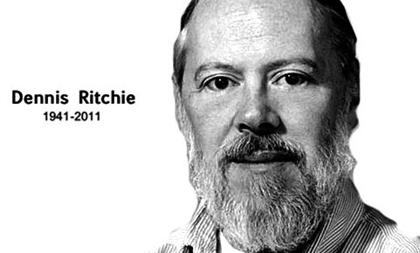

The origin of C is closely tied to the development of the Unix operating system, originally implemented in assembly language on a PDP-7 by Dennis Ritchie and Ken Thompson, incorporating several ideas from colleagues. Eventually, they decided to port the operating system to a PDP-11. The original PDP-11 version of Unix was

developed in assembly language. The Fig:1.1:Dennis Ritchie.

developers were considering rewriting the system using the B language, Thompson's simplified version of BCPL. However B's inability to take advantage of some of the PDP-11's features, notably byte addressability, led to C. The name of C was chosen simply as the next after.

The development of C started in 1972 on the PDP-11 Unix system and first appeared in Version 2 Unix. The language was not initially designed with portability in mind, but soon ran on different platforms as well: a compiler for the Honeywell 6000 was written within the first year of C's history, while an IBM System/370 port followed soon.

Also in 1972, a large part of Unix was rewritten in C.By 1973, with the addition of struct types, the C language had become powerful enough that most of the Unix kernel was now in C.

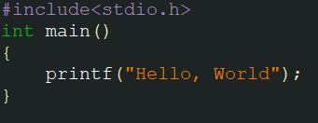Unix was one of the first operating system kernels implemented in a language other than assembly. Earlier instances include the Multics system which was written in PL/I), and Master Control Program (MCP) for the Burroughs B5000 written in ALGOL in 1961. In around 1977, Ritchie and Stephen C. Johnson made further changes to the language to facilitate portability of the Unix operating system. Johnson's Portable C Compiler served as the basis for several implementations of C on new platforms.

Fig 1.2: C programing language.

**1.3 Conclusion:**

In this chapter we know a short history of C programming and how much it’s daily life use. We also know how much this programming language upgrade day by day.

**Chapter 2: Background:**

**2.1 Introduction:**

In this chapter we discuss about our inspiration of our project. After inspiration we started to make this project by help the honorable sir MD. Habibur Rahman. For his help we make this project success.

**2.2 Background:**

Now we live in digital world. World changes with new new new technology. So people upgrade their thinking and make all things easy for them. Nowadys people can send their money at any place in at any time and it’s to easy to transfer money from ATM and its safe.

In this project we just worked in simple logic. The project based on some function and some if else logic. And we use c programming logic in home page to show the Display for Choose the “Home Page”.

The project idea is how an ATM booth work. we try to make this possible.

**2.3 Conclusion:**

I this project we try to implement our study of programming in our pratical life. We done our best to able this project success in implementation.

**Chapter 3: METHEODOLOGY:**

**3.1 Introduction:**

In this we discuss about some logic or methods which we use in this project. We also discuss every header file and their including functions elaborately. We also describe our working procedure step by step.

**3.2 Header Files:**

Table :1.1: Header Files

|  |  |  |
| --- | --- | --- |
| **Serial No.** | **Header Files** | **Description** |
| **1.** | **#include<stdio.h>** | **This header file declare the standard input output.** |
| **2.** | **#include” Mb Final”** | **This header file is declare a program in background. This header file use for some function to use** |
| **3.** | **#include “ Atm Card”** | **This header file is declare a program in background. This header file use for some function to use** |
| **4.** | **#include ”Create account”** | **This header file is declare a program in background. This header file use for some function to use** |

|  |  |  |
| --- | --- | --- |
| **Serial No.** | **In Build Function** | **Description** |
| **1.** | **Printf()** | This function is used to print the character, string, float, integer, octal and hexadecimal values onto the output screen |
| **2.** | **Scanf()** | This function is use to read the character, float, integer values to read the program. |
| **3.** | **While()** | This function is used to give condition on program. |
| **4.** | **If()** | This function is used to give condition on program. |

**Some in built function are:**

Table 1.2: Some built Function

**3.3 Welcome page:**

First We use printf() to use display the Home page menu:

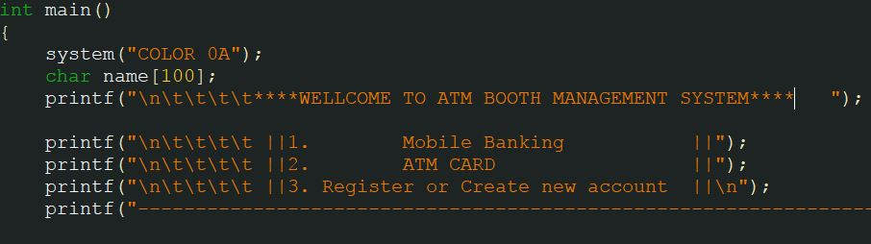

**Fig 2.1: Welcome Page.**

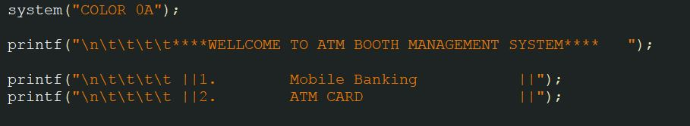**Then we use scanf() function to input the Choice of user want to use:**

**Fig 2.2: Scanf() function**

**Then we use String Compare to Use Simple Log in System:**

**Fig 2.3: String Compare** 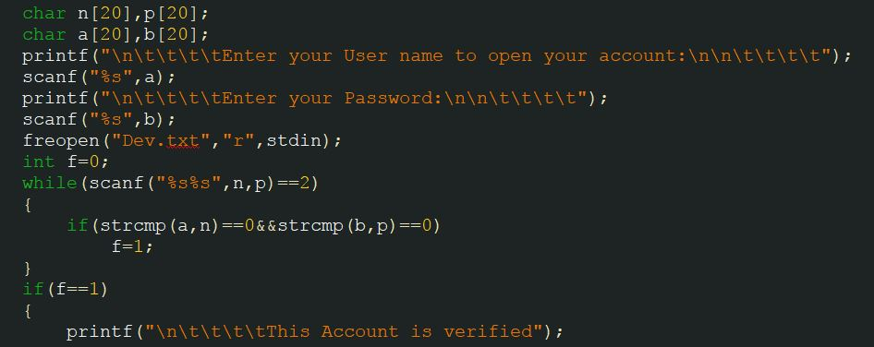

**3.3 Conclusion:**

**In this chapter we discuss about interface of project and also discuss what kind of function use in program.**

**Chapter 3: Result of Project:**

**4.1 Introduction:**

In this chapter we represent our experimental result.

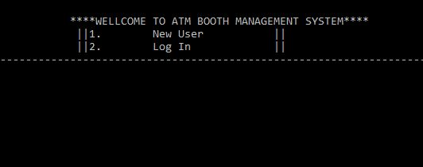**4.2.1 Welcome page:**

Fig 3.1: Welcome page output

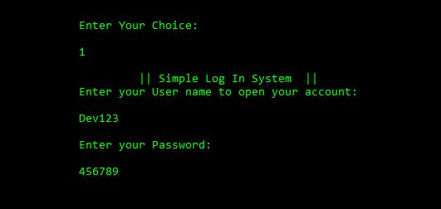**4.2.2 Simple Log in system:**

Fig 3.2: Simple Log in system

**4.2.3 Mobile Banking page:**

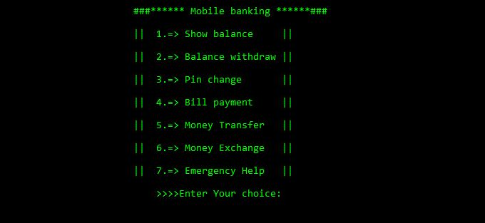

Fig 3.3: Mobile Banking Output

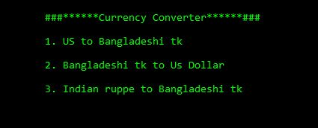**4.2.4 Money Exchange:**

Fig 3.4: Money Exchange Output

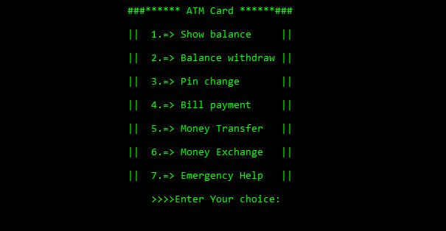**4.2.5 ATM card Page:**

Fig 3.5: Atm card Output

**4.2.6 Account Create Page:**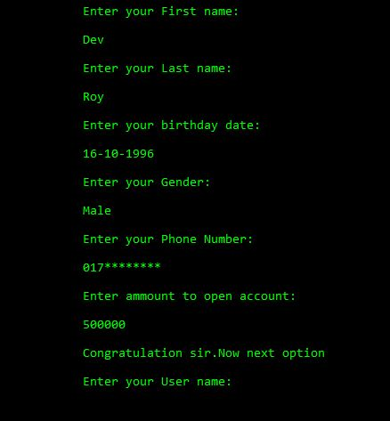

Fig 3.6: Account create Output

**4.3 Conclusion:**

Here we discuss about the output of our project.

**Chapter 4: Reference:**

For any help Book: ”let us C”..

Website: www.codeforwin.org

**Appendix:**

**Here is the main Code:** [**http://codepad.org/0Kw445Rb**](http://codepad.org/0Kw445Rb)

**And Other Sub code are here:** [**http://codepad.org/sVjWVpBY**](http://codepad.org/sVjWVpBY)

**and**

[**http://codepad.org/1eKTjJG5**](http://codepad.org/1eKTjJG5)

**and**

[**http://codepad.org/rIqTgjj8**](http://codepad.org/rIqTgjj8)